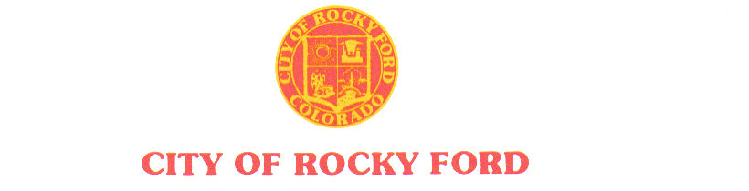

203 South Main * Rocky Ford, CO 81067 * (719) 254-7414 * Fax (719) 254-7416 ______________________________________________________________________

AGENDA

Regular City Council Meeting

Tuesday, February 26, 2019

*- The order and times of agenda items are approximate and intended as a guideline for the City Council –*

|  |  |
| --- | --- |
| Item # | Worksession – 6:00 PM |
| 1. | Introduction of new employees |
| 2. | Empty Building Registry/lagoons/water update - Long |
| 3. | Budget – Auditors |
| 4. | Grand Stands fair grounds |
|  | **Recess** |
|  | Regular Council Session – 7:00 PM |
| 1. | Call to Order |
| 2. | Roll Call |
| 3. | Pledge of Allegiance |
| 4. | Approval of Minutes from February 12, 2019 Regular Meeting |
| 5. | Citizen Participation – 3 minute time limit  *Citizen participation is for items not otherwise on the agenda* |
| 6. | Approval of Agenda and Consent Agenda |
|  | a. Approval of special event license – RF Chamber of Commerce, Mar 25, 2019 |
|  | b. Approval of Fermented Malt Beverage License – J.R.’s Country Store, 1207 Elm, RF |
| 7. | New business items |
|  |  |
|  |  |
| 8. | Staff Reports |
|  | 1. Interim City Manager – Wallace |
|  |  |
| 9. | RFRFD agreement |
| 10. | Mayor City Council Reports/updates |
|  |  |
| 11. |  |
| 12. | Citizen Participation – 3 minute time limit  *Citizen participation is for items not otherwise on the agenda* |
| 13. | Items for Consideration at Future Meeting |
|  | *Golf Course Lease;; Departmental Reports; Gobin’s agreement; School board work session*  *Review city codes* |
|  |  |
|  |  |
|  | Adjournment |