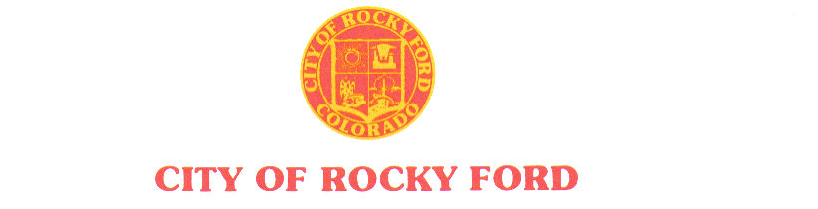

203 South Main * Rocky Ford, CO 81067 * (719) 254-7414 * Fax (719) 254-7416 ______________________________________________________________________

AGENDA

Regular City Council Meeting

Tuesday, June 11, 2019

*- The order and times of agenda items are approximate and intended as a guideline for the City Council –*

|  |  |
| --- | --- |
| Item # | Worksession – 6:00 PM |
| 1. | Beautification committee |
| 2. | Museum committee |
| 3. | Benefit Health Advisor |
|  | **Recess** |
|  | Regular Council Session – 7:00 PM |
| 1. | Call to Order |
| 2. | Roll Call |
| 3. | Pledge of Allegiance |
| 4. | Approval of Minutes from May 28, 2019 Regular Meeting |
| 5. | Citizen Participation – 3-minute time limit  *Citizen participation is for items not otherwise on the agenda* |
| 6. | Approval of Agenda and Consent Agenda |
|  | 1. Budget Calendar |
|  | 1. Hotel & Restaurant Liquor License Renewal – 10th Hole Bar & Grill, 91 Play park Hill, Rocky Ford, CO |
|  | 1. Permission for youth wellness to use streets around Library park for 5K run on 8/10/19. |
| 7. | Ordinance # 944- Vacating of property |
| 8. | Ordinance # 945 - 1% sales tax |
| 9. | Resolution #3 – To participate in November Election |
| 10. | New Business items |
|  | 1. Dangerous building ordinance |
|  | 1. Beautification Committee |
| 11. | Staff Reports |
|  | City Manager- Shannon Wallace |
| 12. | Mayor City Council Reports/updates |
| 13. | Citizen Participation – 3 minute time limit  *Citizen participation is for items not otherwise on the agenda* |
| 16. | Items for Consideration at Future Meeting |
|  | *Departmental Reports; Gobin’s agreement (letter sent); School board work session****(meet in July)****; Review City Codes****(need suggestions where to start);****City Property sale; Employee Benefits;* |
| 17. | Adjournment |
|  |  |
|  |  |
|  |  |
|  |  |
|  |  |